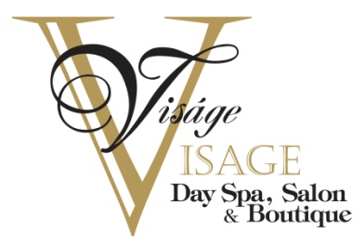

Special Occasion Agreement
Thank You for choosing Visage A' Visage for your most memorable moments!

In order to keep one of the busiest days of your life stress free we would like to coordinate with one Person/Wedding planner or Host (liaison of event). This will ensure that there is no confusion when payments are processed or if there are any changes that may need made during this exciting time. Therefore, NO individual payments will be accepted by any party members.

To further simplify your Visage experience, we will be adding 20% gratuity to your parties tab. Once all the planning is set and you are ready to book with us we will need a $100.00 deposit to hold your reservation and lock in the prices shown on our Wedding Party Menu. This $100.00 deposit will then go toward your bill due upon the day of servicing. As you already know, you will be able to enjoy the entire third floor bridal suite. The day of the event you will be accommodated with light refreshments, you are even welcome to bring your own bottle of wine or champagne! However, under NO circumstances will any food be permitted in the Mansion.

If E-mailing or faxing:
Please type your name and date at the bottom of this form, your electronic signature will be your acknowledgement of the terms and conditions written above. We so look forward to making your day a very special one.
If in person:
Please sign and print your name below to acknowledge your acceptance of our terms. Thank you so much!

X _________________________ X _________________________Printed Name X _______________Date Signed

802 North Duke Street, Lancaster PA 17602
717-299-5315 www.visagevisage.com
Email: visage802events@yahoo.com

